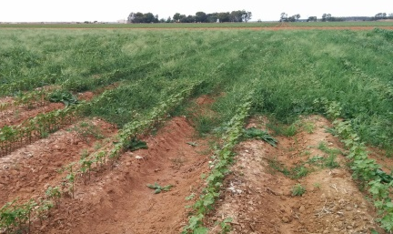 | Tuesday 22nd January, 2019  8.30 to 11.30am  COME CLEAN GO CLEAN  Please bring clean vehicles | 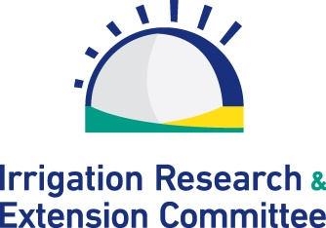
IREC FIELD DAY

Please join us for an update on the range of trials
being held at the IREC Field Station

Topics include:

- Pump Automation - Dallas Stott (Bidgee Automation)
- Black Root Rot & Silver Leaf Whitefly Update - Kieran O’Keeffe (CottonInfo)
- N Trial - Ben McDonald and Dio Antille (CSIRO)
- Manure Trial - Dr Wendy Quayle (Deakin University) - Long term benefits of using animal manures.
- Herbicide Demo - Eric Koetz (NSW DPI/CottonInfo) - evaluating pre and post-emergent chemistry, residual & layby herbicide applications.
Integrating chemical and non-chemical tactics.
- K Trial - Jim Laycock (Incitec Pivot)

Other Speakers: Rob Houghton (IREC), Luke Testoni (Nufarm) & Scott Golding (Sipcam)

Where: IREC Field Station - Stott Road, Whitton NSW

Breakfast: BBQ breakfast

RSVP by Friday 18th January, 2019

IREC: 02 6963 0936 Iva: 0402 069 643 e. irec@irec.org.au |  | www.irec.org.au

